CSCI 5380

Network Virtualization and Orchestration

Lab 3

OpenStack: Service-Chaining

University of Colorado Boulder

Department of Computer Science

Network Engineering

Professor Levi Perigo, Ph.D.

# **PART 1: Service chaining**

# Summary:

In this part, you will manage service chaining in OpenStack.

# Section 1: In-network service chaining:

Create the service chaining in Figure 2 according to the lecture instructions.

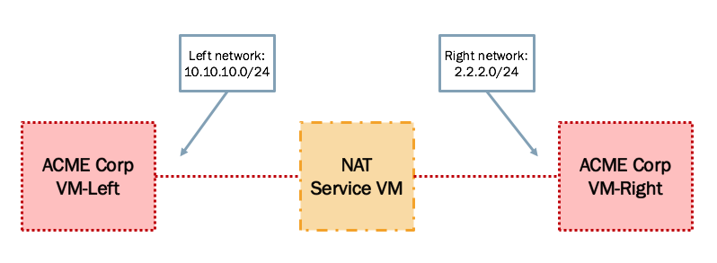

Figure 2. In-Network Service Chaining setup

You can either create your own NAT VM appliance or download and use one from another source such as: [pfSense](https://github.com/OverFlowJAMK/General/wiki/Installing-PFSense-into-OpenStack).

# Section 2: Transparent service chaining:

Add a Layer 2 firewall to the setup in Section 1. The firewall will block SSH protocol on port 22. The setup will look like Figure 3.

You may want to create your own Firewall VM or use the pfSense appliance mentioned in previous section.

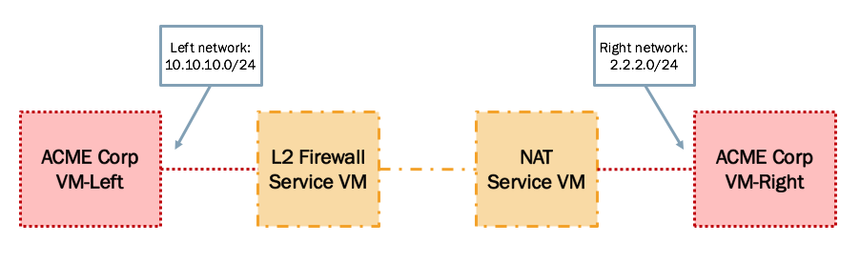

Figure 3. Service Chaining with L2 Firewall

# Deliverable (100 points):

Create a tutorial document indicating the steps to achieve this lab.